Assignment 3

# Part A

## 1.

The EU country administrative border datasets were published to the SDE database using the *feature class to feature class* tool in ArcGIS Pro. For the keyboard configuration PG_GEOMETRY was used.

## 2.

Ein Bild, das Text enthält.
Using the *share as web layer* functionality in ArcGIS Pro, the dataset is shared to the portal similar to the instructions from the publishing exercise in class (see figure 1).

Figure 1.: Sharing the web layer

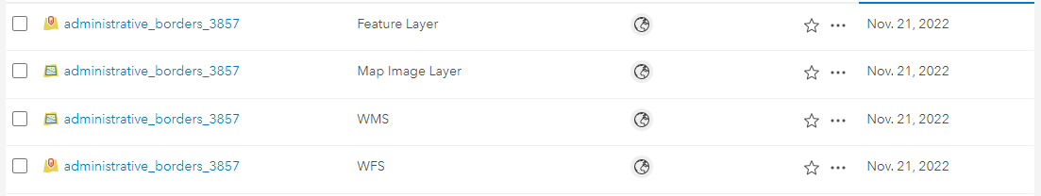The data then can be viewed in the geoportal (see figure 2).

Figure 2.: According layers uploaded to the Geoserver

## 3. & 4.

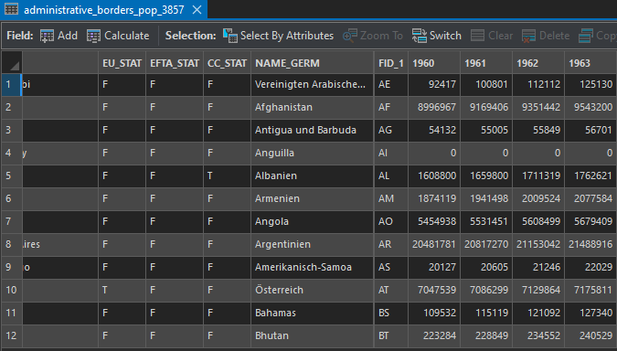Using QGIS the downloaded table was added. Using the *join* functionality, the population data was added to the shapefile and then exported to a new shapefile (see figure 3 and 4). For some reason this didn’t seem to work in ArcGIS Pro (trying to open the table resulted in a crash).

Ein Bild, das Text enthält.

Figure 4.: Joining the data in QGIS

Figure 3.: Attribute table of new shapefie in ArcGIS Pro

## 5. & 6.

Same procedures as in numbers 1 and 2.

The shapefile was added to the database and shared as web layer to the portal.

## 7.

## 8.

# Part B

## 11.

Metadata for the feature layer (figure 5)

Ein Bild, das Text enthält.

Figure 5.: Metadata

Link to data:

<https://zgis216.geo.sbg.ac.at/server/rest/services/22W856162/administrative_borders_pop_3857/FeatureServer/0>

Link to Web App:

<https://geoportal22s.zgis.at/portal/apps/webappviewer/index.html?id=fe7a619b69eb4e1db6df5c3d59f3d833&extent=-12754103.6566%2C-3599027.4005%2C16989072.7897%2C12603176.611%2C102100>

Link to Web Map:

<https://geoportal22s.zgis.at/portal/home/webmap/viewer.html?webmap=5e83fdf7d285463ba881d1b8823dae47>